Game Engines Task 1

mcast | Institute for the creative Arts

INT 5.2A

Luke micallef | aNDY aTTARD

[Year]

***Basic Description***

**Our game will be called Touchdown. Reference is made to the American Football sport. The game will be an endless 2D runner, an American football player will be running through the field, the players will get a side few of the character and he will be able to jump, and increase/lower his speed. The character will be able to catch balls which spawns in the air, most of them you will need to jump in order to catch, once you catch the balls, you will be able to throw them either at the obstacles spawning, or at the goalpost to score points. You can also pick up a power up which provides you with 10 more balls to throw. Below is a reference of how the game view will look like. In addition to catching balls, the player will also need to avoid the enemy which will be rushing towards him. He can time his jump and take down his opponent by landing on him, get hit by the opponent, and you will lose the game, you can also loose the game by hitting the obstacle. The player can collect protein shakes which gives him an energy boost and also adds a multiplier to the score. There will be a game manager, which enables you to pause the game, and also keeps a high score.**

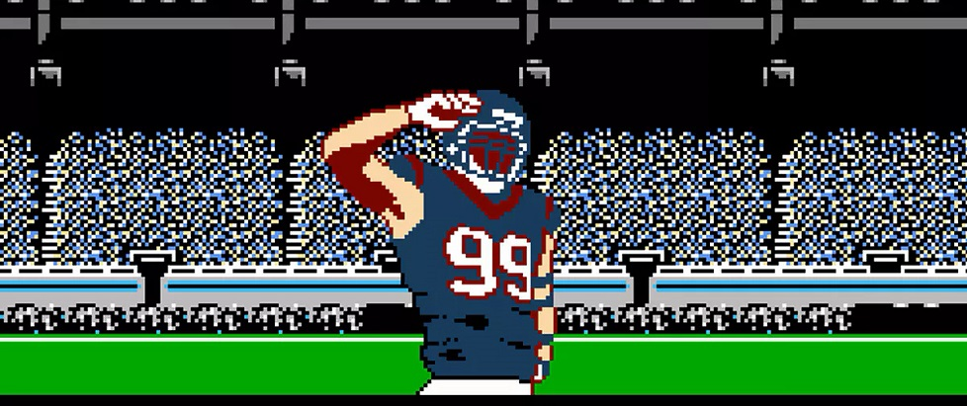**The images were found from google images. The character will be created in photoshop and will not look like the one in the picture.**

***Player (reference)***

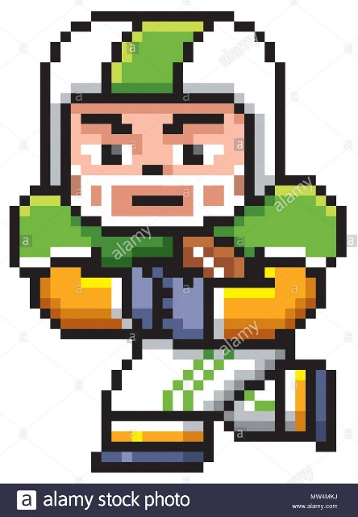

***Ball (reference)***

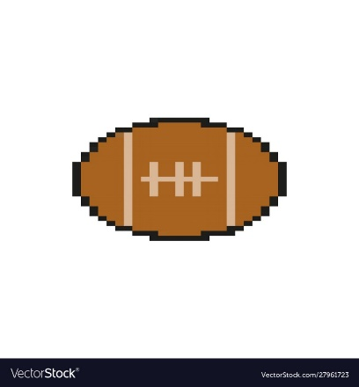

***Protein Shake (reference)***



The protein shake will be made in photo shop in an 8-bit version, picture above is only for reference.

***Gantt Chart***

We decided to go with the waterfall system design model. We feel that this is the most straight forward and easy to understand model. We did some research on it too see how it would normally be used and we created a Gantt chart showing different tasks we will be doing on different dates, following this model.

***Requirement analysis - 14th- 18th December***

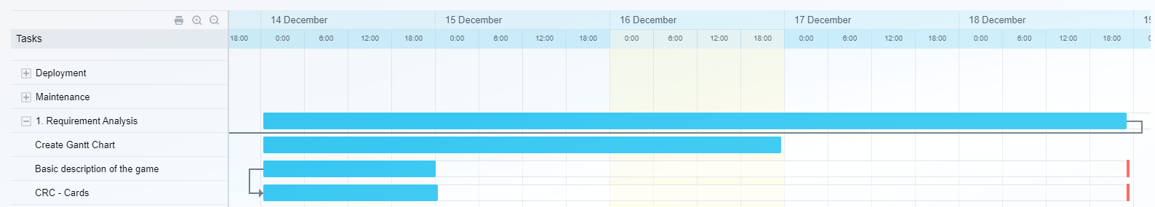

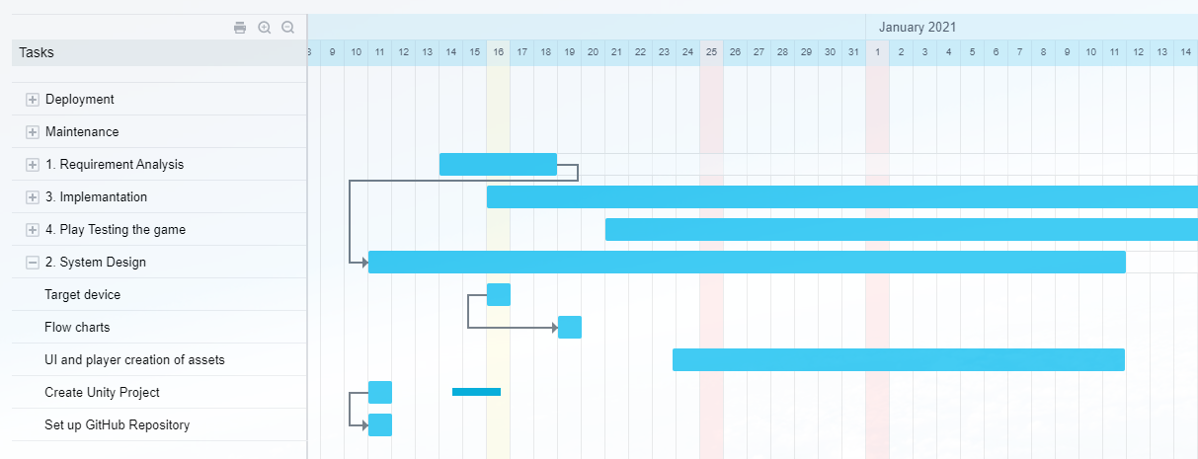***System Design - 11th December - 11th January***

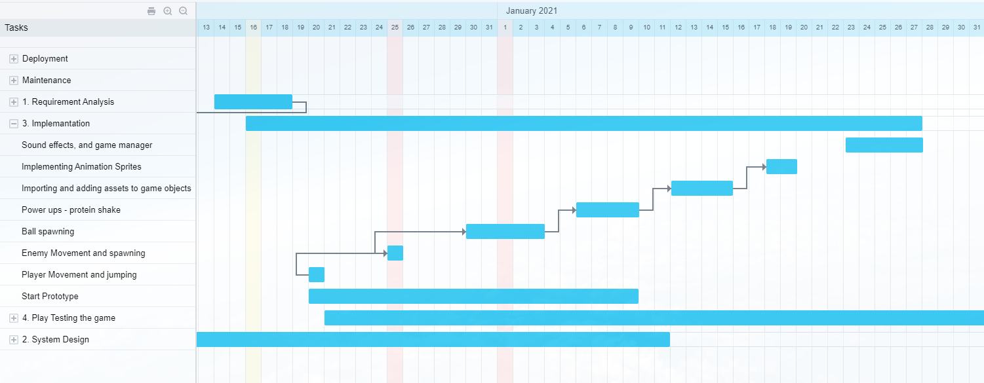***Implementation – 16th December - 27th January***

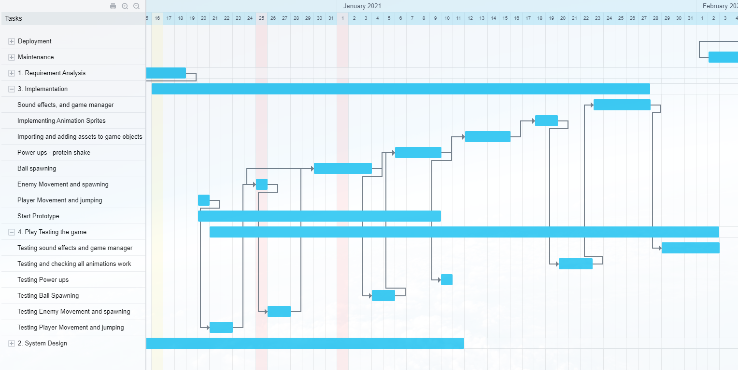***Playtesting - 21st December - 2nd February***

With regards to the play testing, as seen in a YouTube video on the waterfall model, when we finish a part from the game, we will be playtesting that part, but only when it is finished.

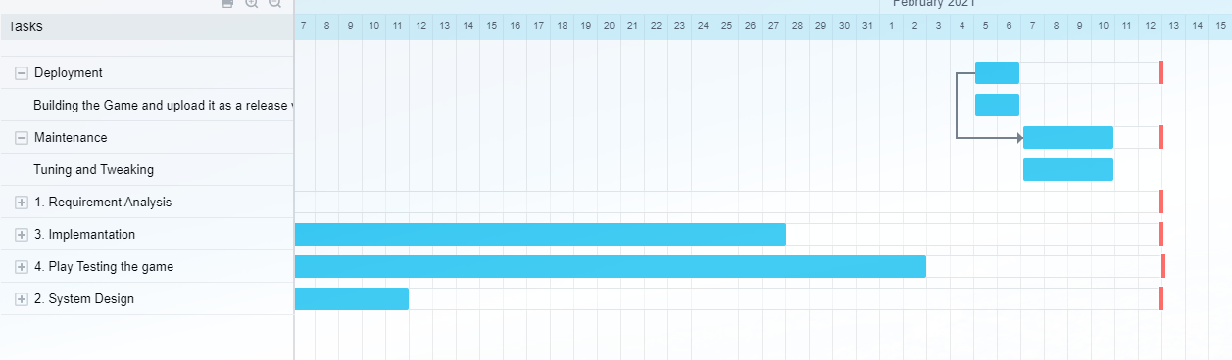***Deployment - 5th February - 6th February***

***Maintenance - 7th February - 10th February***

***CRC Cards***

